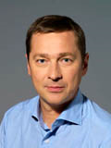
Mr. ARTŪRAS ZUOKAS
Mayor of Vilnius City

Artūras Zuokas is a multi-dimensional leader whose career has thus far spanned transitions from journalism to entrepreneurship to politics.
As a war correspondent, he provided first-hand televised reports for British and Lithuanian media from combat zones located in countries as distant as Iraq, Chechnya, Georgia and Azerbaijan.
Feeling the need for new challenges, Artūras Zuokas turned to the political arena. After successfully managing several national and municipal level campaigns, he was elected Mayor of Vilnius, Lithuania in 2000 and served until 2007. In April 2011 he was elected Mayor of Vilnius for the 3rd time.
During his first two terms in office as one of the youngest mayors of a capital city in Europe, Artūras Zuokas quickly established a strong track record for breakthrough problem solving and fast results that re-shaped the urban landscape of post-Soviet Vilnius. He was subsequently elected to Parliament where he became Chairman of the Liberal Center Union’s faction and headed the Lithuanian delegation to the European Security and Defense Assembly. In June of 2010, Artūras Zuokas founded a new grass roots movement in Lithuania whose focus is on creative solutions to issues of topical concern.
Artūras Zuokas is an innovative and strategic alliance builder in the public and private sectors and was twice elected Vice-President of the Organization of World Heritage Cities. He was Chairman of the Board of the Vilnius - European Capital of Culture 2009 program and has spear-headed large-scale projects of economic and cultural significance in Lithuania. He was instrumental in founding the Jonas Mekas Visual Arts Center in Vilnius and recently established The Ministry of Fluxus, a center for cutting edge and experimental art.
Artūras Zuokas is the recipient of numerous international and national awards and honors. He received this year's Ig Nobel Peace Prize for using an armoured tank to fight the problem of illegal parking in the capital city of Lithuania. He was decorated by President Jacques Chirac of France with the Order of the Legion of Honor and President Vaira Vike-Freibergs of Latvia for his contribution to the betterment of bi-lateral relations. The Junior Chamber International recognized Artūras Zuokas for his administrative achievements by naming him one of the Ten Outstanding Young Leaders in the World in 2002.
He is one of the founding members and current Executive Director of the Azzara Foundation and a long-time member as well as past President of the Rotary Club in Lithuania. Artūras Zuokas was elected to the Board of Directors of Anthology Film Archives in 2009.

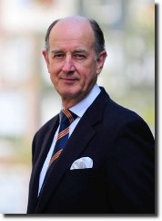
Mr. PAUL HOHNEN
CEO Sustainability Strategies, Amsterdam

Paul Hohnen has worked intensively since 1975 on a range of global economic, development and environmental issues as a diplomat, international civil servant, Director of Greenpeace International, and Strategic Director of the Global Reporting Initiative (GRI). Now an independent consultant, his clients include governments, intergovernmental agencies, business and non-profit organisations. Trained as an international lawyer, Hohnen worked from 1975 to 1989 as an Australian diplomat at the OECD in Paris, to the EU institutions, and in Fiji and Sri Lanka. He was closely involved in the 1992 and 2002 Earth Summit processes, and has participated in the negotiation of a wide range environmental conventions, including on climate change. Paul Hohnen is an Associate Fellow of the Royal Institute for International Affairs (Chatham House), chair of the SRI Advisory Committee of Henderson Global Investors, a Special Adviser to the GRI, a Senior Consultant to the International Institute for Sustainable Development (IISD), and Adviser to the Earth Charter.


Mr. CONOR RIFFLE
Head of CDP Cities

Conor Riffle serves as Head of CDP Cities, a position he has held since June 2010. In this role, he oversees the growth and expansion of the Cities program. Prior to his role at CDP, Conor served in various roles at the William J. Clinton Foundation in New York, including Foreign Policy Fellow and as a member of the team that developed and ran the second annual Clinton Global Initiative in 2006. At the Clinton Foundation, Conor was an early employee of the Clinton Climate Initiative (CCI), where he worked with large city governments around the world—including Karachi, Tokyo, and Seoul—on greenhouse gas reduction projects and helped to set up CCI offices in North America, Asia, and Africa. Conor holds a BA from Connecticut College and an MA from the London School of Economics.

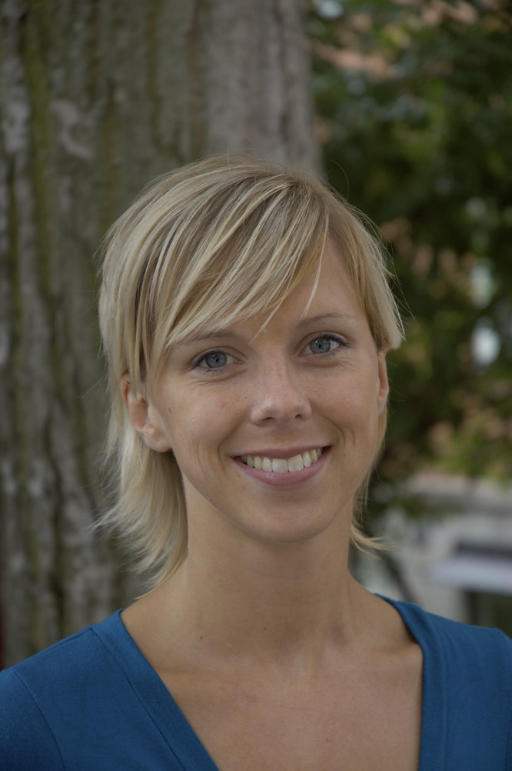
Ms. LINDA PERSSON Environmental Strategist at the Executive Office in the City of Stockholm
Linda Persson currently works as Strategist at the Strategic Urban Development Unit at the Executive Office in the City of Stockholm. When Stockholm was appointed European Green Capital 2010 by the European Commission, Linda Persson became the project manager. She has worked within the City of Stockholm with international and environmental issues since 2006. Previously Ms. Persson has worked for the Swedish Environmental Protection Agency with local investment programs. She holds a Degree of Master of Political Science with specialization in Environment.

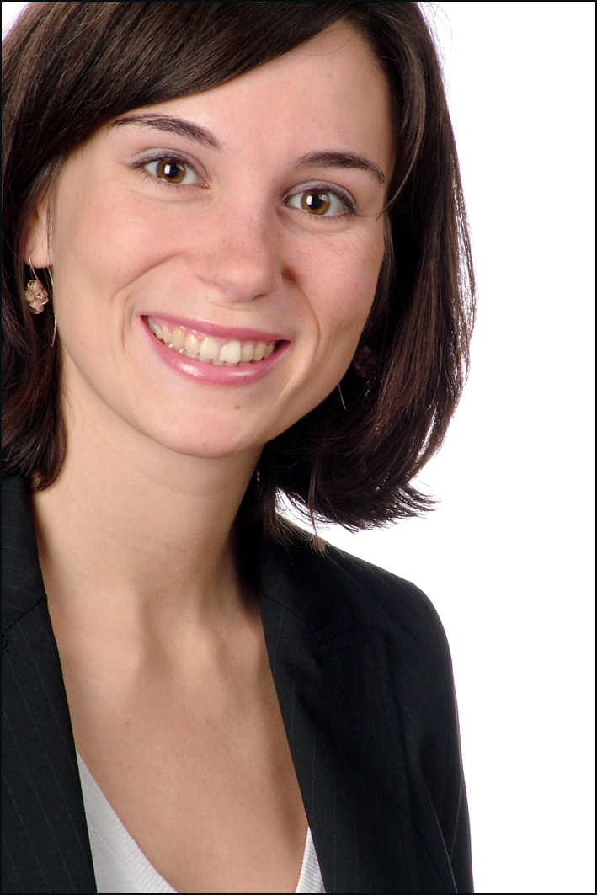
Ms. KAREN STELZNER
Project Manager Green City Index, Corporate Communications, Siemens AG, Munich

Karen Stelzner has been the project manager of the Green City Index, a unique research project evaluating the environmental sustainability of more than 120 cities worldwide. The study is conducted by Siemens in cooperation with the Economist Intelligence Unit. The series started with the European Green City Index published in 2009, and was then followed by further publications on major cities in Latin America (2010), Asia, Germany and USA/Canada (all 2011). A study on major African cities is currently underway and will be published end of 2011 in Durban during COP 17.
Ms. Stelzner is working for Corporate Communications - Issues Management at Siemens AG, based in Munich, Germany. Her work includes sustainable cities communication and managing research projects on urban sustainability. Ms. Stelzner joined Siemens in July 2007 and has been working in different positions at Corporate Communications, both in Munich and Bangkok. She holds a masters degree in communication sciences, sociology and business from the University of Leipzig, Germany.

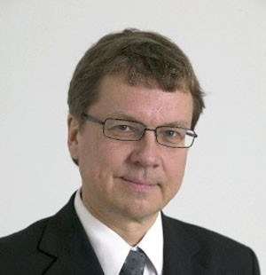
Mr. PEKKA SAURI
Deputy Mayor of the City of Helsinki
Pekka Sauri has served as Deputy Mayor of the City of Helsinki since 2003, in charge of Public Works and Environmental Affairs. He was elected to the office as a Finnish Green League Party member by Helsinki City Council, first for a seven-year term, and re-elected for another seven years in 2010.
Prior to his current office, Dr. Sauri served in various positions in mental health counseling in Finland in 1975-2003. He was Chairman of the Green League of Finland in 1991-1993. He also worked as a radio journalist in 1996-2002. Dr. Sauri’s long list of positions of trust over the past 21 years, both in Finland and internationally, include chairmanship of the European Federation of Green Parties in 1994-1997. Dr. Sauri holds a Doctor of Philosophy degree from the Brunel University, London, UK.

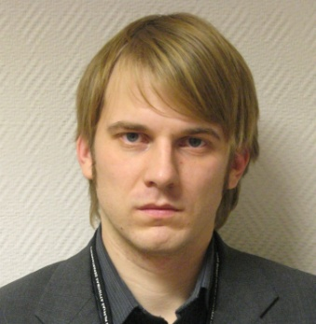
Mr. MARTINS MENNIKS
Head of International Project Division, City Development Department, Riga City Council

Martins Menniks has become Head of International Project Division, Riga City Council’s Development Department, Economical Board in January 2008. Parallel he is involved as Coordinator Baltic sea region program project EcoRegion and several investment projects financed by the EU. Mr. Menniks started to work for Riga City Council’s Development Department, Economical Board in May 2006 as Specialist of Investment and Development Project Division. In January, 2007 he became Chief Specialist of Investment and Development Project Division at Riga City Council’s Development Department, Economical Board. He also acted as Head of EU Grant program “Technical help for Self governments and NGO to strengthen they capacity”. From 2004 till 2005 he was Project Coordinator of Project and International Relations Division, Valmiera City Council.

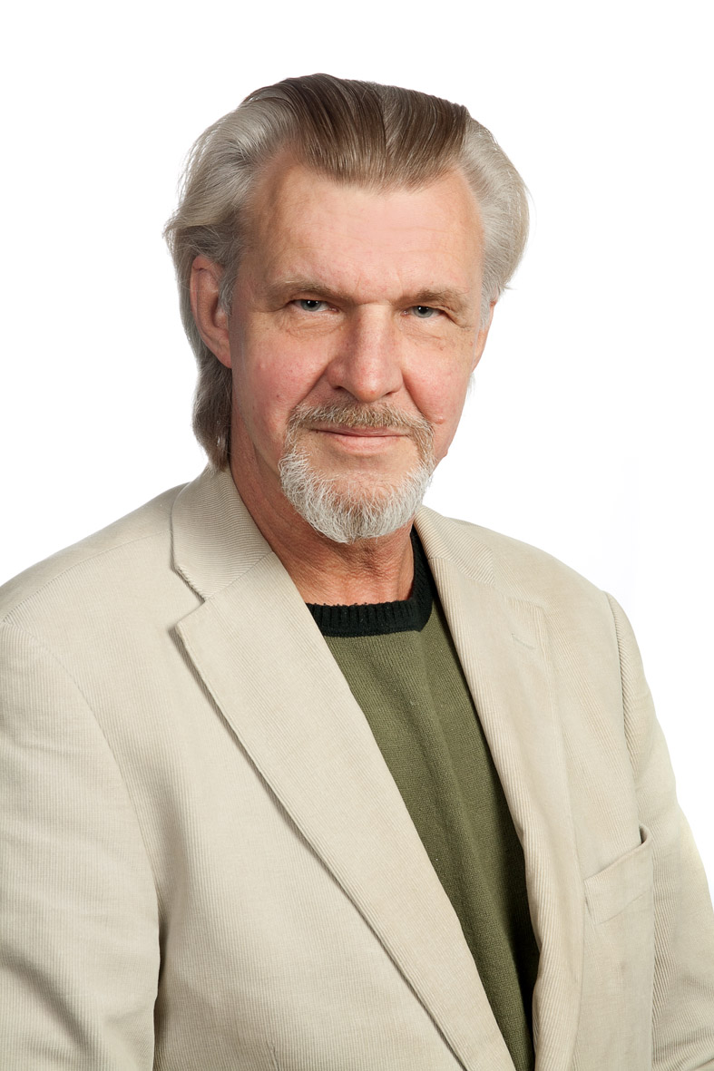
Mr. RAIVO KIIS
Project Manager in Tallinn Environment Department
Raivo Kiis holds Master degree in Psychology from Tartu University and Bachelor degree in International Affairs and European Integration from Estonian School of Diplomacy 2003. Mr. Kiis has experience in public service as senior clerk 11 years. Now is occupied as project manager for European projects in Tallinn Environment Department.

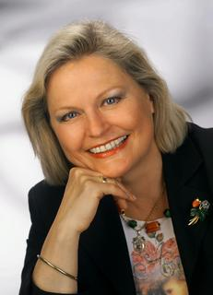
Prof. Dr. ELISABETH VITOUCH
Member of the City Council, President of the European and
International Affairs Commission of the Vienna City Council
Elisabeth Vitouch is a member of the Vienna City Council and Provincial Parliament for the Austrian Social Democratic Party since 2001. Spokesperson on film matters in the Cultural Affairs and Science Committee of the Vienna City Council. Member of the Tourism Commission, the Duties Appeals Commission, the Special Needs Commission, the Vienna Historic Town Preservation Fund and the Incompatibility Commission, as well as board member of the Dr. Karl Renner Award and vice chairperson of the European Affairs Commission in the City Council of Vienna. Since 2007 - President of the European Affairs Commission in the Vienna Diet. Since 2010 President of the Committee for European & International Affairs. Member of the Committee of the Regions (CoR) in Brussels, political group coordinator of the EDUC expert commission on Education, Training and Cultural affairs. Chair of the PES-women in the CoR. Since 2010 member of the jury for the European Capital of Culture (ECOC). Ms. Vitouch holds a university degree (Dr.phil.) in Romance languages and psychology from the University of Vienna.


Ms. INDRĖ KLEINAITĖ
Independent Sustainability Expert, NGO „Gyva LT“, Vilnius

Indrė Kleinaitė is the independent sustainability and business responsibility expert, member of Association of Sustainability Practitioners (ASP) in UK, member of advisory group for National Sustainable Development Strategy under the supervision of Environment Ministry in Lithuania. She runs an NGO „Gyva LT“ to promote environmentally friendly living, responsible business practices and sustainable development in Lithuania.
Since 2003 Ms. Kleinaitė has worked in partnerships with international, non-governmental, state and private institutions in various sustainability related projects and has been cooperating with media in promoting sustainable development, corporate responsibility, ethical consumption and environmentally friendly living ideas in Lithuania. Between 2007-2009 she worked at UNDP Lithuania on the regional EC project to promote CSR practices and at Nordic Council of Ministers’ Office in Lithuania on the project to promote responsible business practices in SMEs. In 2008 European Commission office in Lithuania awarded her vision for Lithuania as the greenest vision. Ms. Kleinaitė obtained MSc in Responsibility and Business Practice at Bath University, UK and a bachelor degree in economics and business administration at Stockholm School of Economics in Riga, Latvia.

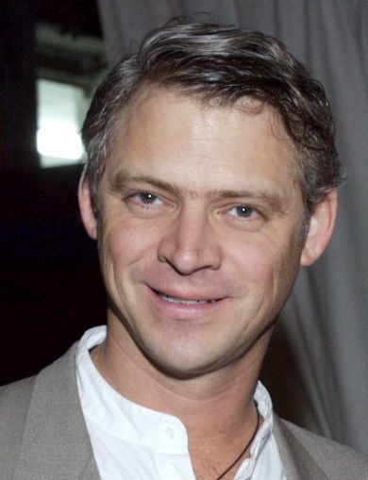
Mr. MURAT ARMBRUSTER
Director, Green Capital Global Challenge
Senior Advisor, Carbon War Room

Murat Armbruster is a founding partner of the clean technology hedge fund, Atlas Capital Investments, LP. After graduating from the University of Michigan with high honors, Murat launched GlobaLearn in 1993, the first K-12 eLearning website to help prepare our nation's children for global citizenship. GlobaLearn was acquired by Houghton Mifflin in 2001 and featured in Don Tapscott's bestselling Growing Up Digital. Murat represented the education sector as a member of the U.S. delegation led by Vice President Gore to the G-7 Information Society Summit. During the 2004 presidential campaign, he served as Deputy Executive Officer to General Wesley K. Clark during his bid to become the Democratic Party's nominee. In 2005, he was a founding partner and Chief Operating Officer of Adina for Life, a San Francisco-based beverage company focused on fair trade and sustainable business practices.


Ms. LAURA DZELZYTĖ
Community Adviser to the Minister of Environment

Laura Dzelzyte is the community adviser to the Minister of environment and the chief architect of Lithuania’s Green Investment Scheme – a financial tool that pools money from carbon trading under the Kyoto Protocol for climate change and renewable energy projects. She is also UN climate negotiator. Laura author and frequent commentator on carbon trading systems and sustainability as well as speaker at international conferences. Laura has been named as Hero of our Time for the work in climate change by the US & Swedish NGO, 2009 and selected as one of the 35 exceptional women under age of 35 in the world as compiled by World Business Magazine in association with Shell – Oct, 2007.

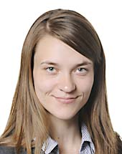
Ms. RADVILĖ MORKŪNAITĖ-MIKULĖNIENĖ
Member of the European Parliament

Radvilė Morkūnaitė is a graduate of the Lithuanian Academy of Music and Theatre (2006) and a graduate of the Vilnius Academy of Fine Arts (culture policy, culture management, 2008).
She has been taking an active part in the political life of Lithuania for more than 10 years now. In 2001 Radvilė became a member of the political party Homeland Union – Lithuanian Christian Democrats (currently – she is a member of the Council, member of the Presidium, member of the Women Community Board). In the same year she joined the Young Conservative League (YCL), and in the period of 2006-2007 she was its Chair.
In the period of 2005-2008 she worked as assistant to various Members of the Parliament of the Republic of Lithuania. From 2008 till 2009 Radvilė Morkūnaitė was adviser to Mr. Vygaudas Ušackas, Minister of Foreign Affairs of the Republic of Lithuania. Since 2007 she has been the coordinator of the project Protect the Baltic Sea while it is not too late.

Radvilė Morkūnaitė was elected a member of the European Parliament in 2009.

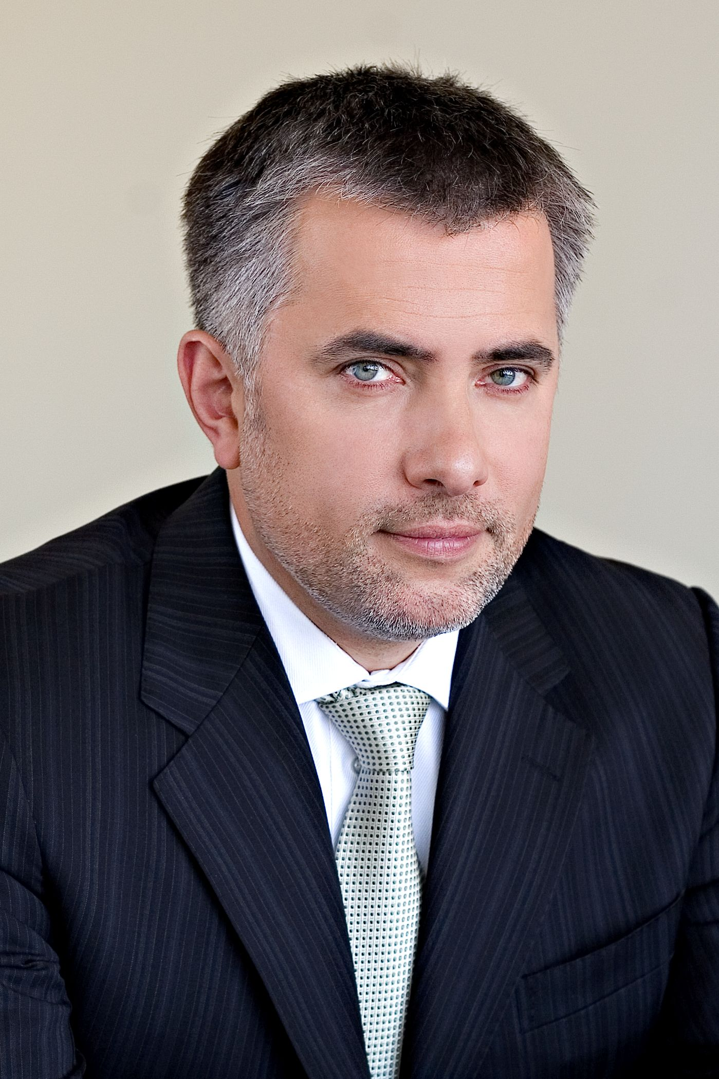
Mr. AUDRIS BARCEVIČIUS
Member of the Board of Siemens Oy (Finland and the Baltics States)

Audris Barcevičius started his career at Siemens in Munich, Germany at R&D application department of Siemens AG Semiconductor Division. In 1995 he was the first local employee who took part in Siemens company establishment and development in Lithuania. For the last 6 years he was also a Member of the board of German-Baltic Chamber of Commerce in Lithuania. Currently he is a Member of the Board of Investors’ Forum in Lithuania.
Siemens is a leading engineering company providing innovative, eco-friendly and energy efficient solutions in the Energy, Industry, Healthcare, and Infrastructure & Cities Sectors. In 2010 Siemens in Finland and Baltic countries reported the revenue of around 320 Mio. Eur. Today Siemens employs about 600 employees in the region.

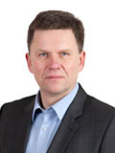
Mr. KĘSTUTIS NĖNIUS
Vilnius City Councillor, Chairman of Economic and Financial Committee

Kęstutis Nėnius accumulated significant expertise in public administration and implementation of infrastructure projects such as street lighting, public transport and energy policy. He has experience in the management of the projects implemented in cooperation with the World Bank and the Government of Lithuania in the public sector. As Director of Vilnius Central Heating Company, Kęstutis Nėnius, is responsible for implementation of the projects related to the modernization of dwelling houses and implementation of energy efficiency measures, development of the residential surroundings and regeneration of the city districts. Significant part of his time is dedicated to projects’ initiation activities, including financial scheme creation for the projects implemented in cooperation with the World Bank, IFC, Commercial Banks and Vilnius City Municipality. Also he is occupied with the market screening, coordination of the preparation of rules for dwelling houses owners associations to participate in the building modernization project and etc.

